Functional Spline Gages

Ever Sharp Tools is a global leader in the design and manufacture of spline gages. Spline ring and plug gages provide the most basic and simple inspection of spline components.
RING GAGES
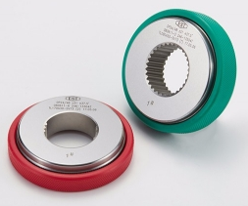
Go Composite Ring Gages provide a basic check of the maximum effective tooth thickness of an external spline component.
No Go Sector Ring Gages provide a basic check of the minimum actual tooth thickness of an external spline component.
No Go Composite Ring Gages provide a basic check of the mini mum effective tooth thickness of an external spline component.

PLUG GAGES
Go Composite Plug Gages provide a basic check of the minimum effective space width of an internal spline component.
No Go Sector Plug Gages provide a basic check of the maximum actual space width of an internal spline component.
No Go Composite Plug Gages provide a basic check of
the maximum effective space width of an internal spline component.
Spline rings and plug gages can also be designed and built for the combined inspection of major or minor diameter fit components. Other elements in the design of a gage can include locating features such as flats and holes in relation to a tooth or space to aid part alignment.

MATERIAL
EST’s gages are made from our proprietary tool steel, with hardness between HRC 60-64; we can also offer an optional cryogenic (chemical freezing) treatment to further harden the material to 65-67 HRC, quoted upon request. Most gage manufacturers use standard tool steel with a hardness range of HRC 60-62. The use of our superior proprietary steel adds to the superior life and wear of our gages, making them a better value!

Contact EST for a quote for your spline gages today!

